1. **Write a query to get a Product list (id, name, unit price) where current products costless than $20.**

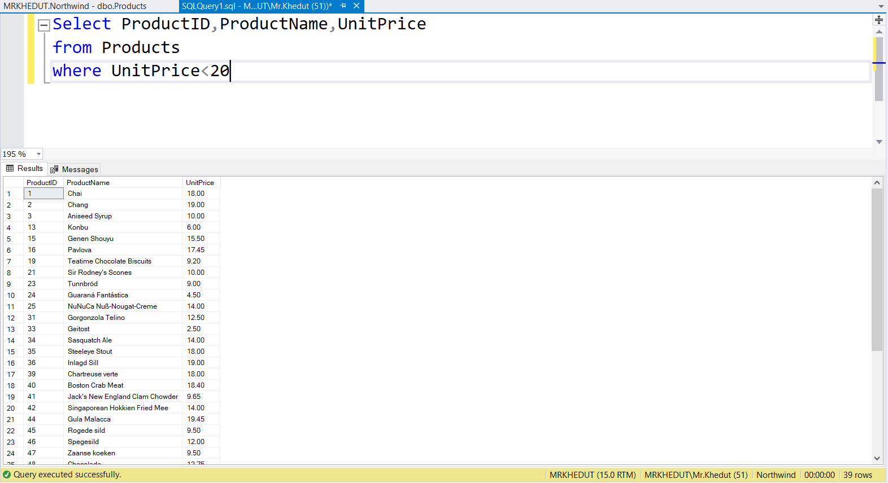

1. **Write a query to get Product list (id, name, unit price) where products cost between $15 and $25**

1. **Write a query to get Product list (name, unit price) of above average price.**

1. **Write a query to get Product list (name, unit price) of ten most expensive products**

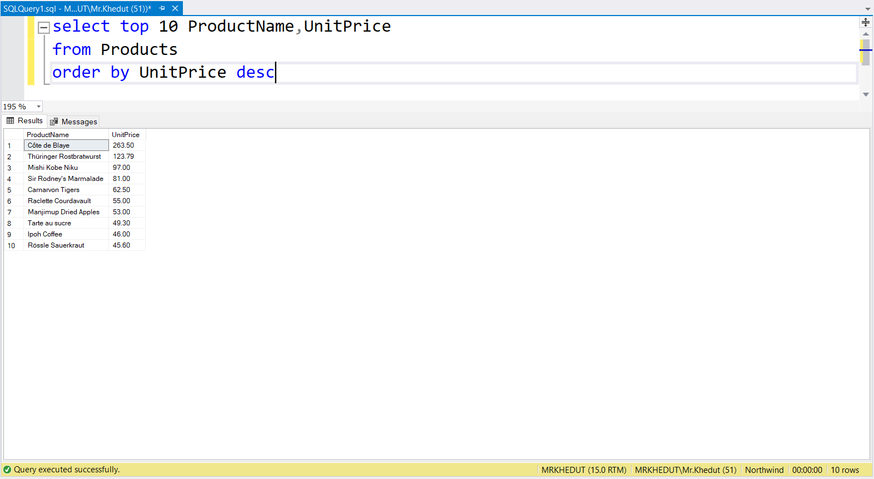

1. **Write a query to count current and discontinued products**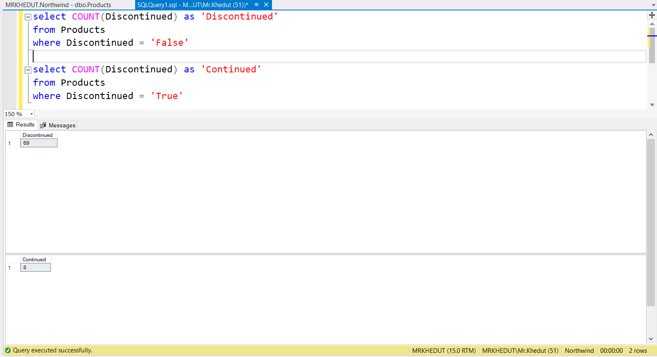
2. **Write a query to get Product list (name, units on order , units in stock) of stock is less than the quantity on order**

